TERM EXMINATION - I
TOTAL MARKS -50
NAME: ____________________
SUBJECT: MATHSMATICS
GRADE: 3 ____
DATE: . 9. 22
TIME : 2 ½ Hours

I. Colour the next pattern (5X1=5)
5
4
3
2
1
II. Fill in the blanks (5X1=5)
6) A triangle has ______ sides
7) A tangram is a set of _______ flat shapes
8) The arrangement of objects repeatedly in a particular order is called a _________
9) We can check our subtraction answer by adding the answer with the ________________
10) The view from the side is called the _______ view
III. Solve the following (7X2=14)
11) Write the number in words
a) 4561 - _______________________________________________
b) 5670 - _______________________________________________
12) Write in expanded form
a) 2306 - ________________________________________________
b) 4900 - ________________________________________________
13) Add the following
a) 3456 + 100 = _________
b) 4210 + 10 = __________
14) Draw diagonal for a square

15) Complete the sequence
a) 5000, 6000, ______, _____, _____, ______
b) 5, 10, 15, _____, _____, ______, ______
16) subtract the following
a) 9819- 100 = ______
b) 8912 – 1000 = ______
17) Create your own (repeating pattern)

IV. Solve the following (5x3=15)
18) Add
a) 4 5 1 9 b) 6 2 4 6
1 5 5 1 +3 3 0 4 +
_______ ______
19) Calculate your age by subtracting the year you were born in form the current year.

_______________________________________ __________

_______________________________________ _________

Ans : _________
20) Write the after number
a) 6782 , ______
b) 2890, ______
c) 1234, ______
21) Subtract
a) 4 5 6 7 b) 2 6 7 0
3 4 7 3 (-) 1 3 5 2 (-)
__________ ________

22) Create own your tessellations with one shape and more than one shape

IV. Write the number faces and edges for each shape (4x1=4)
26
25
24
23

V. Complete the growing pattern (4x1=4)
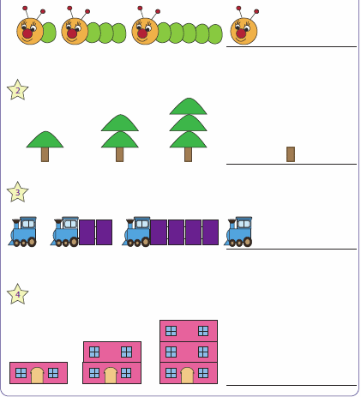
VI. Write addition and subtraction facts using the numbers (3)
- 45, 15 and 60
Addition fact ______________ , _____________
Subtraction fact _____________. ____________
- 70 , 45 and 25
- Addition fact ______________ , _____________
- Subtraction fact _____________. ____________

